

**Ain Shams University**

**Faculty of Computer and Information Science**

**Scientific Computing department**

**Ain shams university**

**Faculty of computer and information science**

**Bioinformatics department**

**Assignment 1 – Deep Learning & Neural Networks Course**

**Single Layer Perceptron**

**By Team: SC_H26**

|  |  |  |
| --- | --- | --- |
| **Name** | **ID** | **Section** |
| **Nour Mohamed Hussein Kamaly** | **20191700701** | **5** |
| **Nourhan Abdel-Karim Khalaf Abdel-Hafez** | **20191700716** | **5** |
| **Mohammed Nour-Elden Abbas Ismael** | **20191700583** | **4** |
| **Abdul-Rahman Sayed Ali Mohammed** | **20191700339** | **3** |

### Table of Contents

## Features Linearity Visualization……………………………………………………….4

Preprocessing…………………………………………………………………………..12

Training………………………………………………………………………………..

## List of Figures

## Features linearity between the 3 classes (10 charts) ………………………………………..4

Features linearity between classes Adelie and Chinstrap (10 charts) ………………………6

Features linearity between classes Adelie and Gentoo (10 charts) …………………………8

Features linearity between classes Chinstrap and Gentoo (10 charts) ……………………..10

## Features Linearity Visualization

1. Between the 3 classes

1. Between class Adelie (red) and Chinstrap (black)

The following combinations can discriminate between the 2 classes:

* Bill length & bill depth
* Bill length & gender

The following combinations can discriminate between the 2 classes but with some error as they are not linearly separable:

* Bill length & flipper length
* Bill length & body mass

The rest of the features cannot be separated linearly at all

1. Between class Adelie (red) and Gentoo (blue)

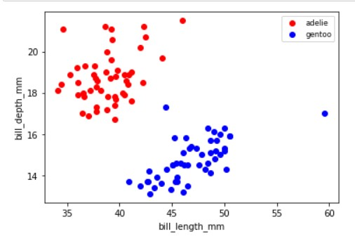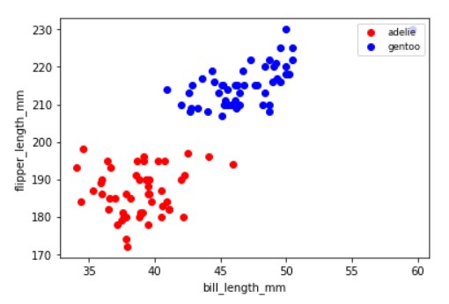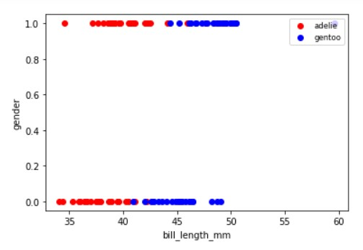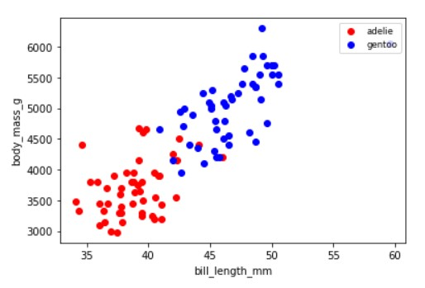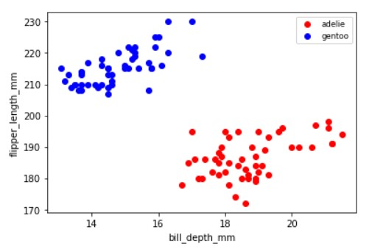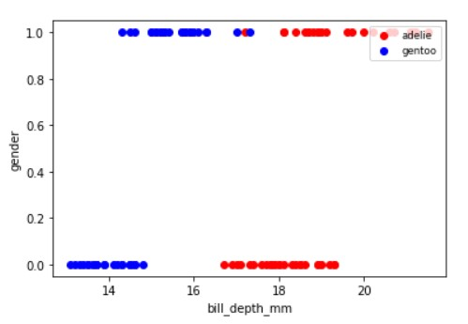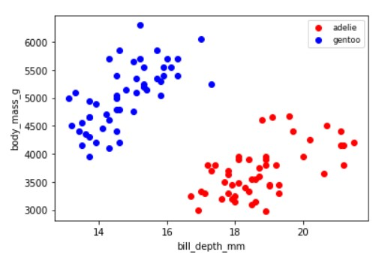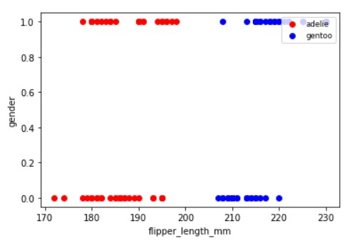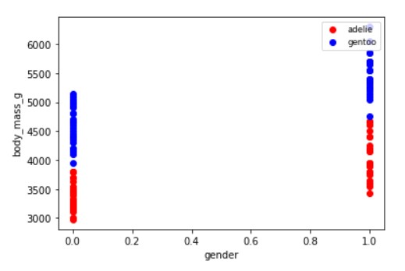

The following combinations can discriminate between the 2 classes as they are linearly separable:

* Bill length & bill depth
* Bill length & flipper length
* Bill depth & flipper length
* Bill depth & body mass
* Flipper length & gender
* Flipper length & body mass
* Gender & body mass

The following combinations can discriminate between the 2 classes but with some error as they are not linearly separable:

* Bill length & gender
* Bill depth & gender (error in 1 point)

1. Between class Chinstrap (blue) and Gentoo (black)

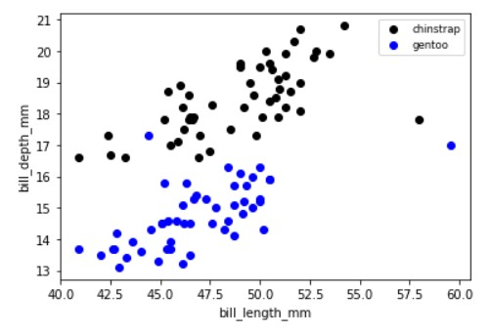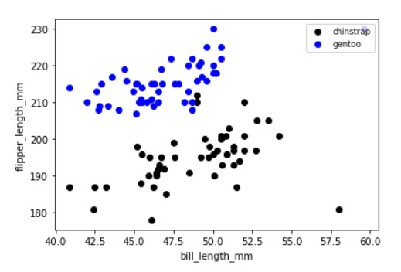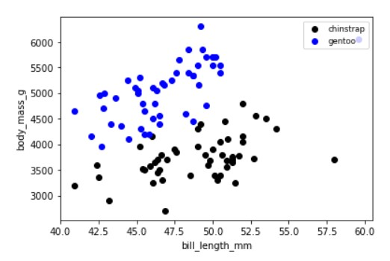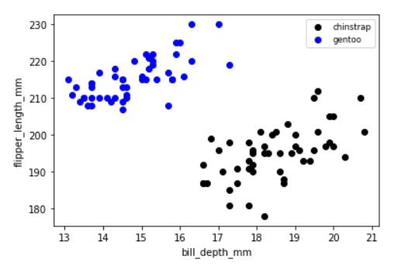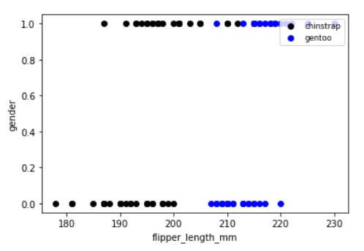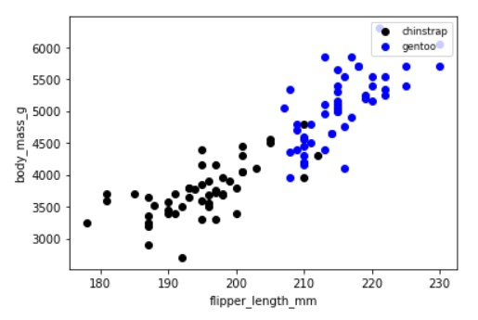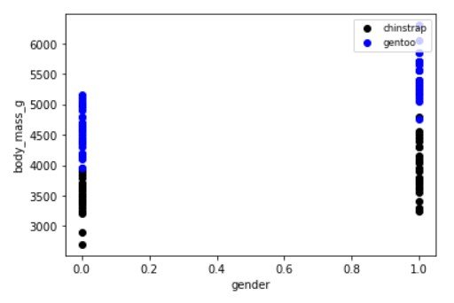

The following combinations can discriminate between the 2 classes:

* Bill depth & body mass
* Bill depth & flipper length
* Bill depth & gender

The following combinations can discriminate between the 2 classes but with some error as they are not linearly separable:

* Bill length & bill depth
* Bill length & flipper length
* Bill length & body mass
* Flipper length & body mass
* Flipper length & gender

**Preprocessing:**

* For numerical features, we checked the skewness and the kurtosis of the feature, all the features had negative kurtosis and a magnitude far from zero and for the skewness.

1. Bill depth skewness had a magnitude close to zero, almost following a normal distribution.
2. All other features’ skewness magnitude was a number far from zero, not following a normal distribution at all.

We tried transforming the numbers using 3 mathematical equations: the square root, log, and the reciprocal of the function, but not one of them resulted in a normal distribution so numbers were kept as they are.

* Gender was the only feature that had null values, 6 null values to be exact, in order to fix that we trained a simple logistic regression model that is able to predict the gender, but we only trained it on two species only as classes (Adelie and Gentoo) were the only classes that had null values, there was no need to train on the other species if they are not present in the null values, we trained on 94 samples on classes (Adelie and Gentoo), the resulting accuracy was 93% and tested on the 6 null values.
* Feature body mass was in grams so we transformed it to kilograms (/1000) so that the range of numbers in the feature would be closer.
* Features (flipper length, bill length, bill width) were in millimeters so we transformed it to centimeters (/10) so that the range of numbers in the feature would be closer.

**Training:**

* The dataset has 3 penguin species (classes) with 50 samples of each class.
* We split the dataset into 30 training samples and 20 testing samples for each class.
* We created "Perception.py" class to make the code more maintainable and extendable.
* The training loop exist inside of method "fit" that's in perception class.
* We built the confusion matrix by looping through the predicted target and actual target and then counting:

1. True positive

2. False negative

3. True negative

4. False positive

* In main file, we first split data into training and testing.

Then we split them further into (X_train, Y_train, X_test, Y_test)

* And we create a perceptron object from class perception and give in the classes that the user selected in the GUI.

The user would select 2 classes and 2 features, and the decision boundary would be plotted:

Supposing that the learning rate is 0.01 and epochs is 1000

1. Between class Adelie and Gentoo

Features: bill_length_mm vs bill_depth_mm, **Accuracy =1**

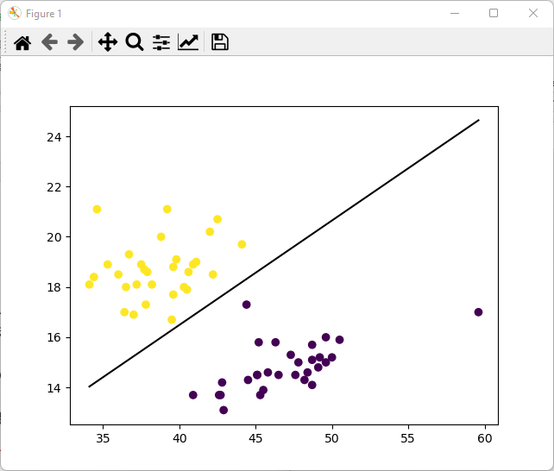

bill_length_mm - flipper_length_mm, **Accuracy =** **0.975**

bill_depth_mm - gender, **Accuracy = 0.975**

bill_length_mm - body_mass_g, **Accuracy= 0.925**

Classes Gentoo & Chinsrtrap

bill_length_mm - body_mass_g, **Accuracy= 0.825**

gender - body_mass_g , **Accuracy = 0.925**

Classes Adelie & Chinstrap:

flipper_length_mm – gender, Accuracy = 0.725

bill_depth_mm - body_mass_g , **Accuracy = 0.5**

flipper_length_mm - body_mass_g , **Accuracy= 0.775**

bill_length_mm - gender , Accuracy = 0.95

**Conclusion:**

Based on the stated results**,**

**Features:**

* bill_length_mm vs bill_depth_mm
* bill_length_mm - flipper_length_mm
* bill_length_mm - body_mass_g
* bill_length_mm - gender
* bill_depth_mm - gender